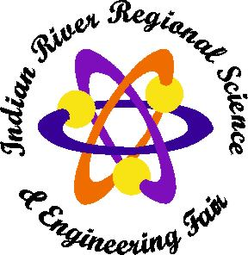
Category: _____________________
Floor/Table: ___________________
Electricity: Yes / No

Secondary (grades 6th -12th) Division Checklist Form
Teachers: Please attach this form on the outside cover of each project folder.
Double-check to make sure that all the forms needed are in this folder and completed properly before submitting to the Education Foundation office.

Form # Form Name:
These forms are required for all projects:
- Abstract Abstract (On Official State Form)
- Form 1 Checklist for Adult Sponsors
- Form 1A Student Checklist
- Research Plan Research Plan
- Form 1B Approval Form
- Form 3 Risk Assessment

These forms may be required depending on the project:
- Form 1C Regulated Registered Research Institutional/Industrial Setting
- Form 2 Qualified Scientist
- Form 4 Human Participants
- Form 5A Vertebrate Animal Form: Research done at non-regulated site
- Form 5B Vertebrate Animal Form: Research done at regulated research institution
- Form 6A Potentially Hazardous Biological Agents Risk Assessment
- Form 6B Human and Vertebrate Animal Tissue Form
- Form 7 Continuation Projects Form (WITH appropriate attachments)

Please be sure to PRINT the students name and project title
PLEASE double check students name and project title for accuracy

Student Name: ____________________________________________________

Teacher Name: ____________________________________________________

School Name: ____________________________________________________

Project Title: _____________________________________________________

The Indian River Regional Science Fair is presented
By the Education Foundation of Indian River County, P.O. Box 7046, Vero Beach, Florida (772) 564-0034, Fax: (772) 564-0761, www.edfoundationirc.org

